Module 7 – Movies Update and Delete
Jacob Richman
Database Development and Use
Due 09/21/26
def show_films(cursor, title):
print("\n-- {} --".format(title))

cursor.execute("""
SELECT film_name AS Name,
film_director AS Director,
genre_name AS Genre,
studio_name AS Studio
FROM film
INNER JOIN genre ON film.genre_id = genre.genre_id
INNER JOIN studio ON film.studio_id = studio.studio_id;
""")

films = cursor.fetchall()

for film in films:
print("Name: {}, Director: {}, Genre: {}, Studio: {}".format(
film[0], film[1], film[2], film[3]
))
# ⭐ Your try block starts HERE
try:
db = mysql.connector.connect(
user="root",
password="Guitarjake15!",
host="127.0.0.1",
database="movies"
)

cursor = db.cursor()

# First display
show_films(cursor, "DISPLAYING FILMS")

# INSERT
insert_query = """
INSERT INTO film (film_name, film_director, genre_id, studio_id)
VALUES ('Inception', 'Christopher Nolan', 1, 2);
"""
cursor.execute(insert_query)
db.commit()
"""
cursor.execute(insert_query)
db.commit()
show_films(cursor, "DISPLAYING FILMS AFTER INSERT")

update_query = """
UPDATE film
SET genre_id = 5
WHERE film_name = 'Alien';
"""
cursor.execute(update_query)
db.commit()

"""
cursor.execute(update_query)
db.commit()

show_films(cursor, "DISPLAYING FILMS AFTER UPDATE")

# ⭐ DELETE
delete_query = """
DELETE FROM film
WHERE film_name = 'Gladiator';
"""
cursor.execute(delete_query)
db.commit()

show_films(cursor, "DISPLAYING FILMS AFTER DELETE")

except mysql.connector.Error as err:
print(err)

finally:
db.close()

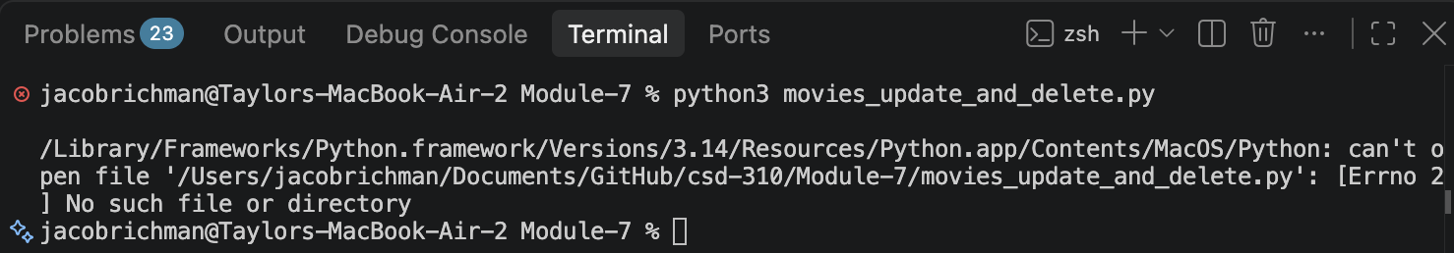

Screenshot: Displaying Films
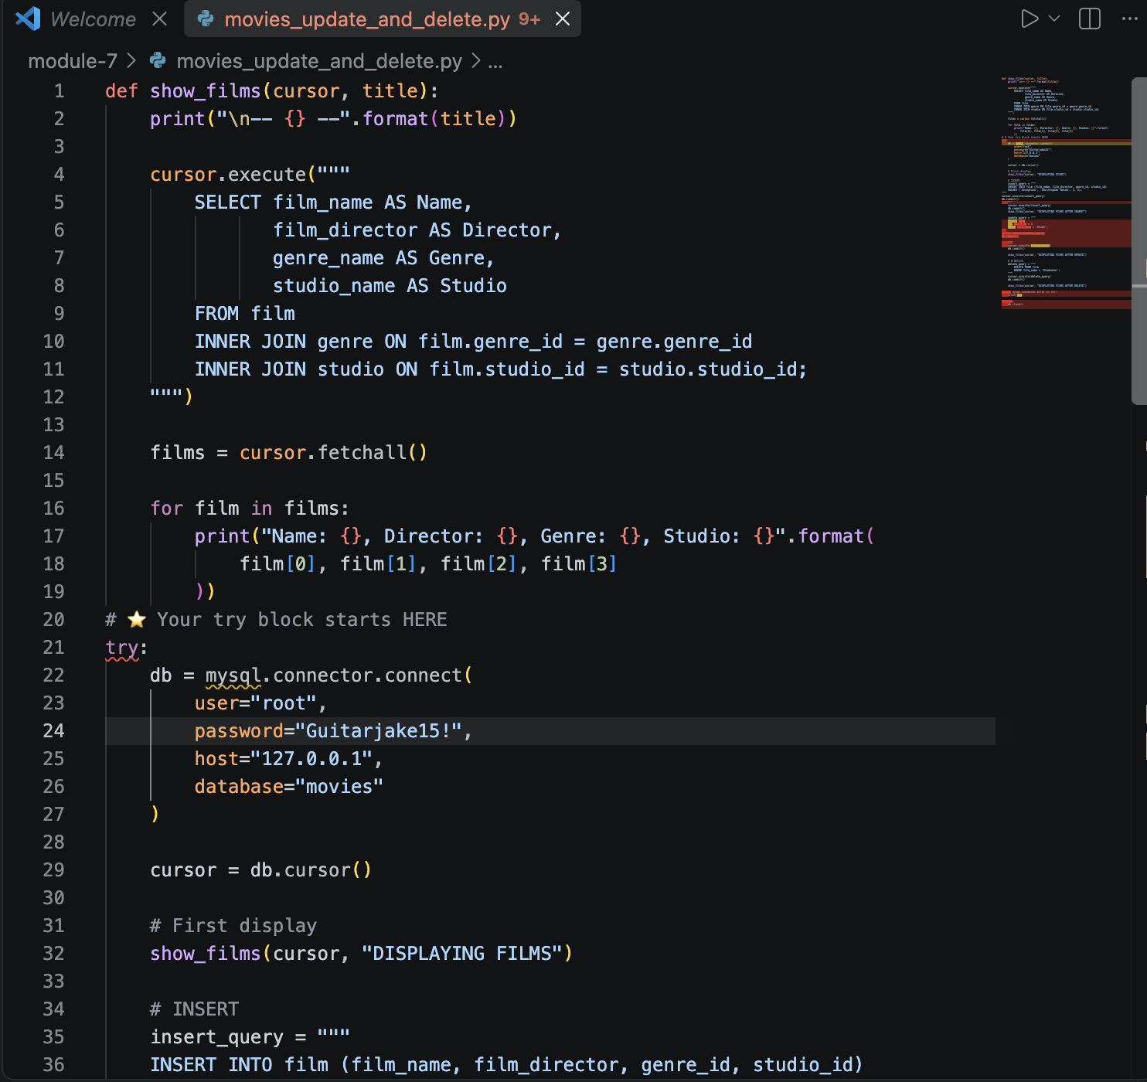
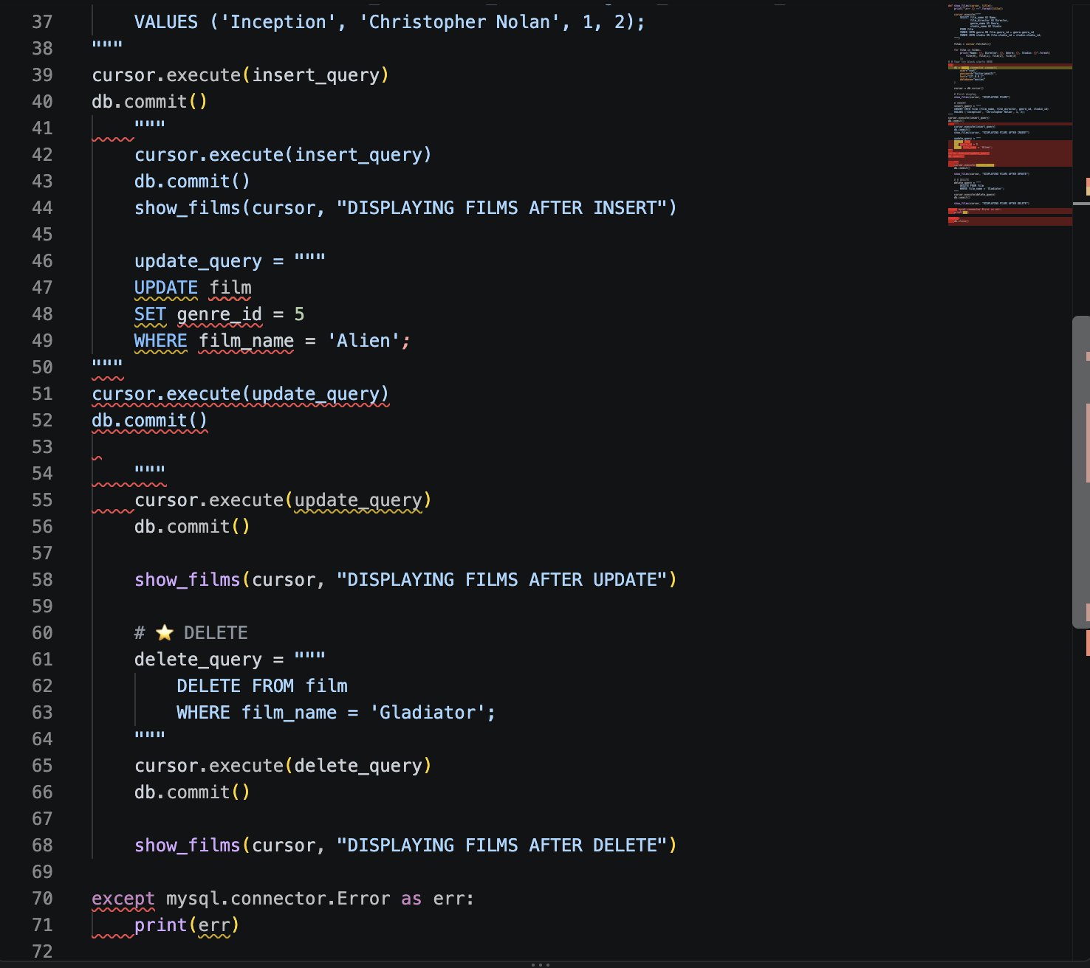

Short Explanations
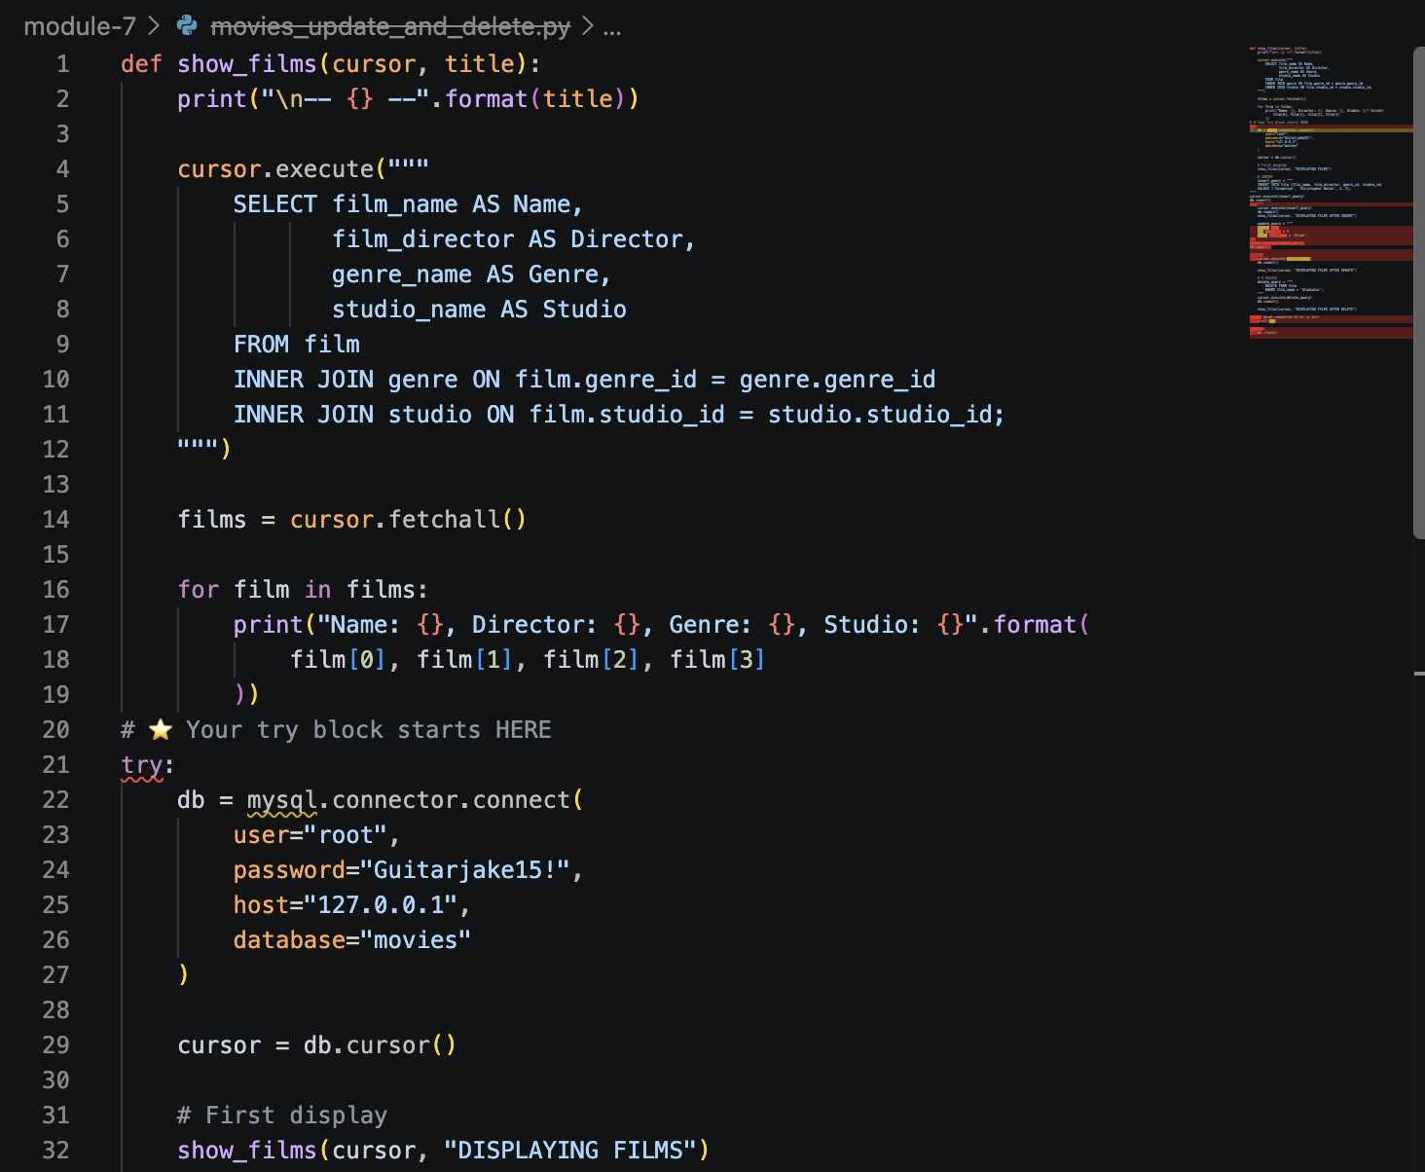
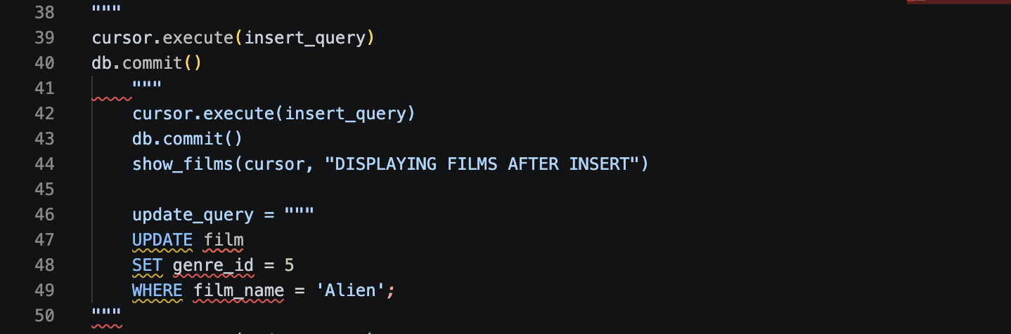
INSERT Operation:
Added the film "Inception" with genre_id 1 and studio_id 2.

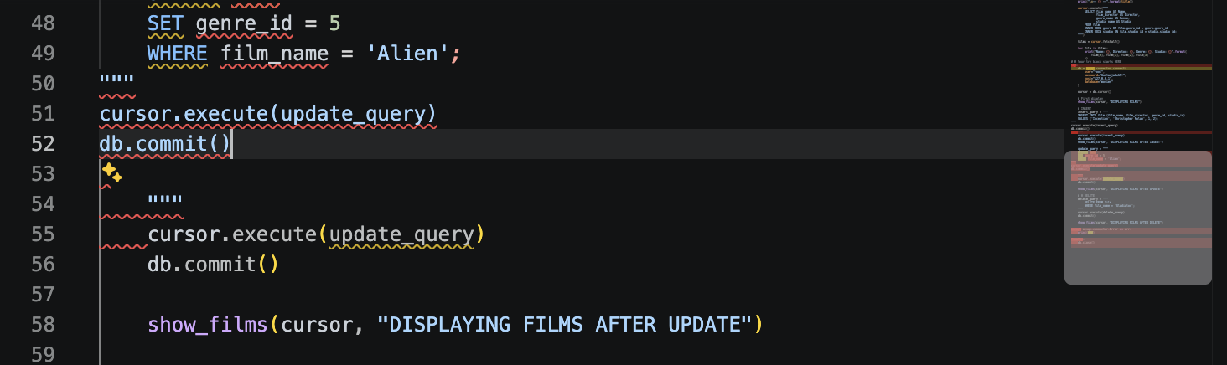
UPDATE Operation:
Changed the genre of "Alien" to Horror (genre_id 5).

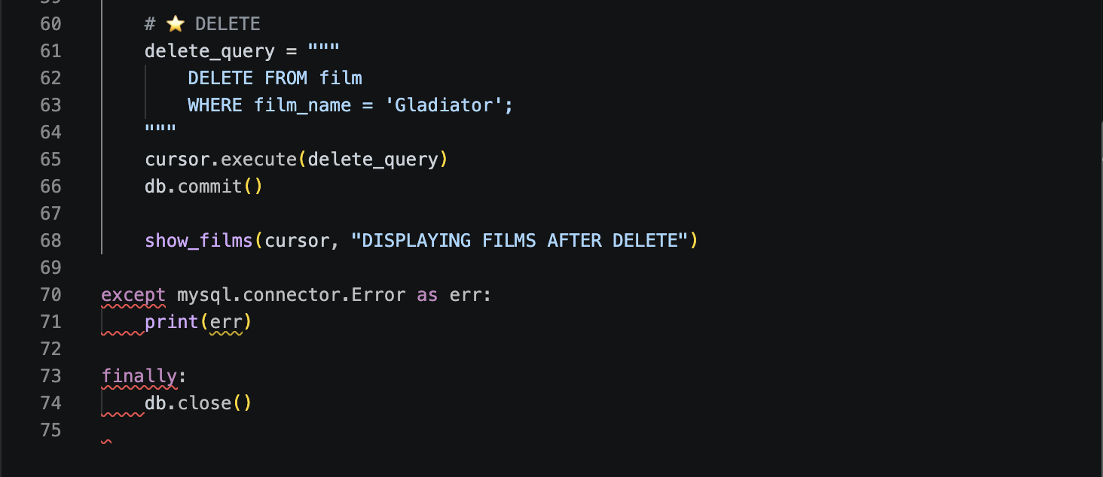
DELETE Operation:
Removed the film "Gladiator" from the film table.

